
Howden St. Andrew’s PS
Family Bulletin-Week Beginning 10th May 2021
Weekly Updates | Marvellous Monday | Terrific  Tuesday | Wellbeing  Wednesday | Thinking  Thursday | Fun  Friday
Mrs Moore’s Message:  It’s Make it Happen May here at HSA! We’re ready to make sure that this term is the best yet! You will receive a Weekly French Family Learning Challenge sent to you by Groupcall. Your Challenge is to take part in Oh La La Vocab each week!  Rule of the Week: Show Consideration and Be Safe  Value of the Week: Peace  Skill of the Month: Confidence  Wellbeing Indicator of the Month: Active  Right of the Fortnight: Education  House of the Week:  Class of the Week:  Pupil Quotes of the Week during a Hashtag Hunt: # # # #  Follow us on Twitter @HowdenStAndrews for regular school and class updates!  Face Book-Howden St. Andrew’s Parent Group  Phone-01506433114  Email: wlhowdenstandrews-ps@westlothian.org.uk  Family Engagement Updates:  Grab a tea or a coffee and please join us for our virtual Build Up Café. Members of the Senior Leadership Team will be on hand for you to ask questions about all things HSA.  The theme of this week's Build Up Café is transition, but all questions are welcome.  https://meet.lync.com/glowscotland/wllouise.mccauley/CQS4RIG1 | 8.15 am Breakfast Club all welcome!     | 8.15 am Breakfast Club all welcome!   | 8.15 am Breakfast Club all welcome!   | 8.15 am Breakfast Club all welcome!  11.15am Ascention Mass via Teams  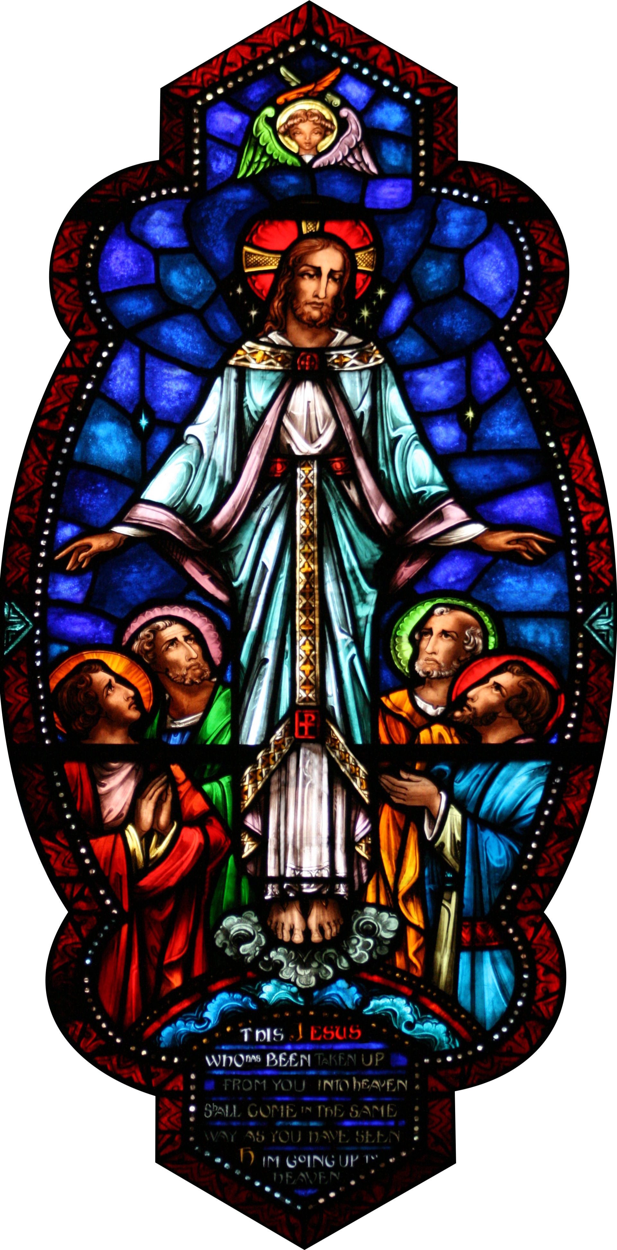 | 8.15 am Breakfast Club all welcome!  9.05am Assembly    10am-Virtual Build Up Café  Feedback Friday    Free Writing Friday    Feel Good Friday    9.10am P6-Litter Audit

